Administrator guide
jWebSocket
C# Client Library
Version 1.0

Version Control
Date | Version | Description | Author
4/3/12 | 1.0 | Creation of the document | Rolando Betancourt Toucet

Process application download

To achieve the correct operation of this library you need to download the following file.

File | Size | Description
CSharpClientLibrary.zip | 137 KB | Contains all binaries for implement a client application.

CSharpClientLibrary.zip contains four important binaries:
File | Size | Description
ClientLibrary.dll | 55 KB | Main file that contains all the business logic.
log4net.dll | 292 KB | Is referenced by ClientLibrary.dll.
JSON.dll | 16 KB | Is referenced by ClientLibrary.dll.
Config.xml | 2 KB | Configuration file.

The URL where it is available for download is: https://jwsdev.org:9443/svn/jWebSocket/branches/jWebSocket-1.0/jWebSocketCSClient/ClientLibrary/

Characteristics of the installation environment
You need to have an environment running Windows XP or any later version. Must have an installation of the Integrated Development Environment (IDE) Visual Studio 2010 with .NET Framework 4.0

Installation process
- Create a form application or console application using the Visual Studio IDE.
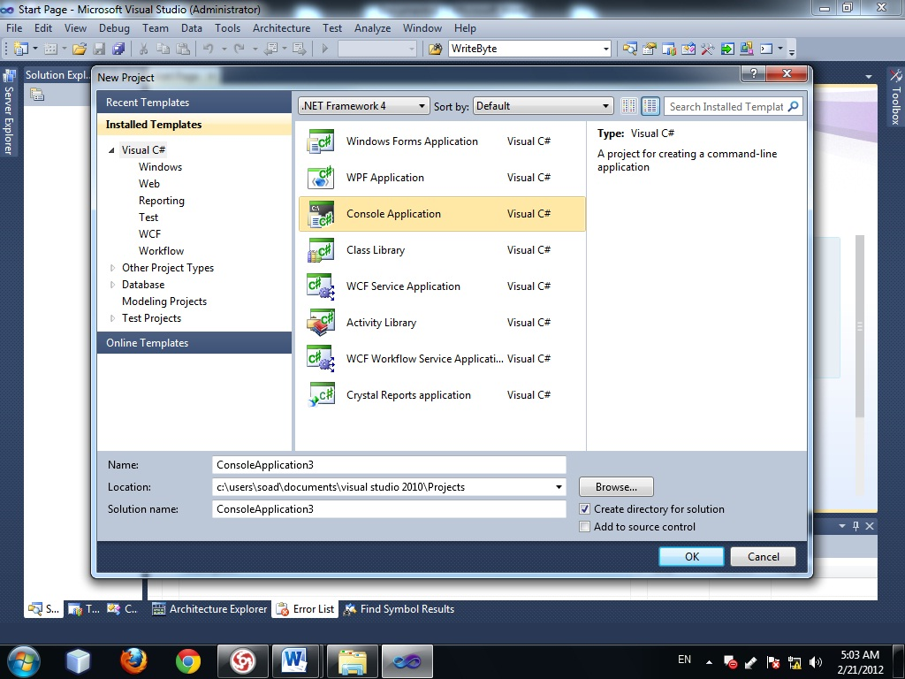

Picture 1: Create application

- Select the Framework 4.0 which is recommended to develop the application.
- Right-click the recently created project, where the menu will to mark the latter option “properties”.
- In the option Target Frameworks we choose .NET Framework 4.0.
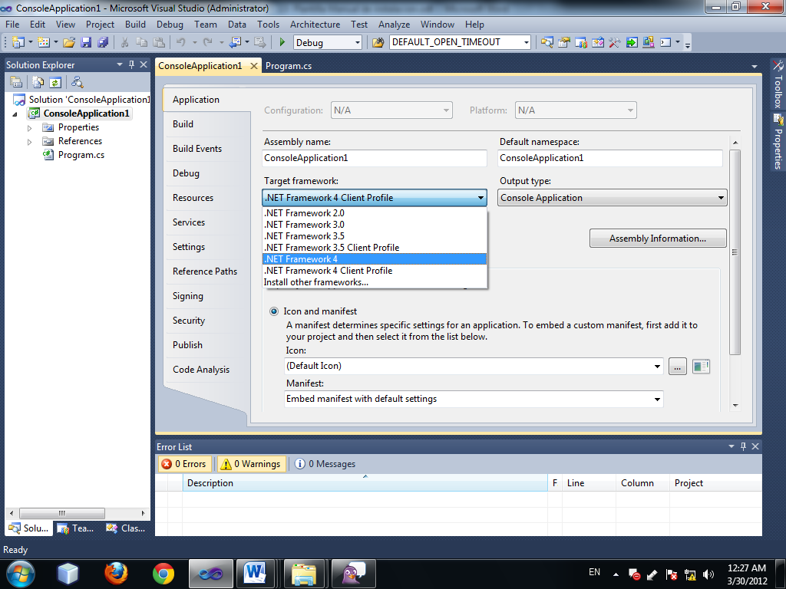

Picture 2: Select Framework

- Must copy the installation files in the root directory of your application to add reference.
- Right click on References and choose the option Add References.
- In the new window choose the tab Browse
- Look root directory and select the files you're going to reference
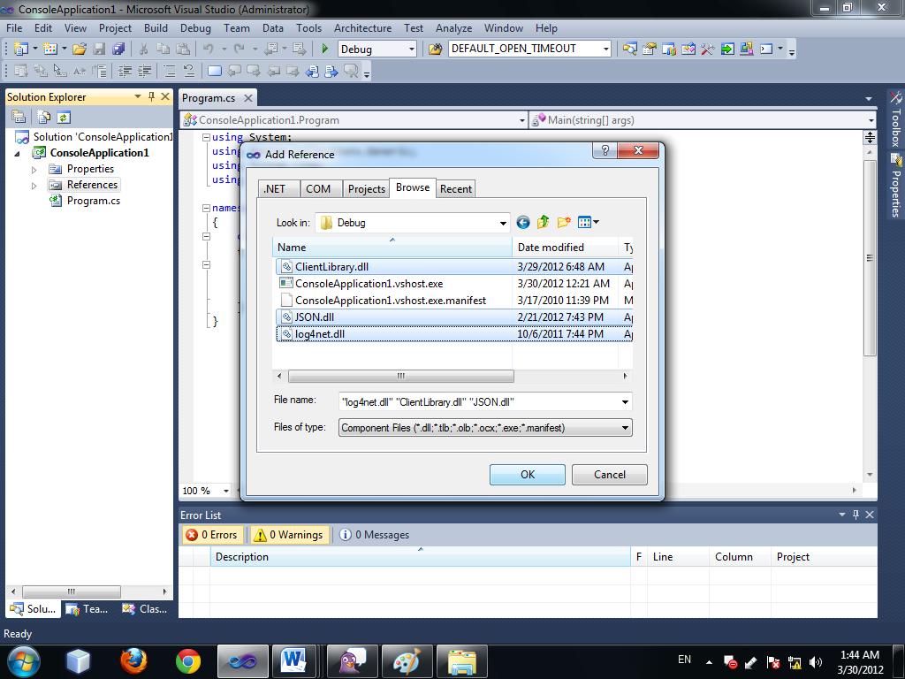
Picture 3: Add reference

- Add the namespace from 3 libraries in class where Let us go to use.
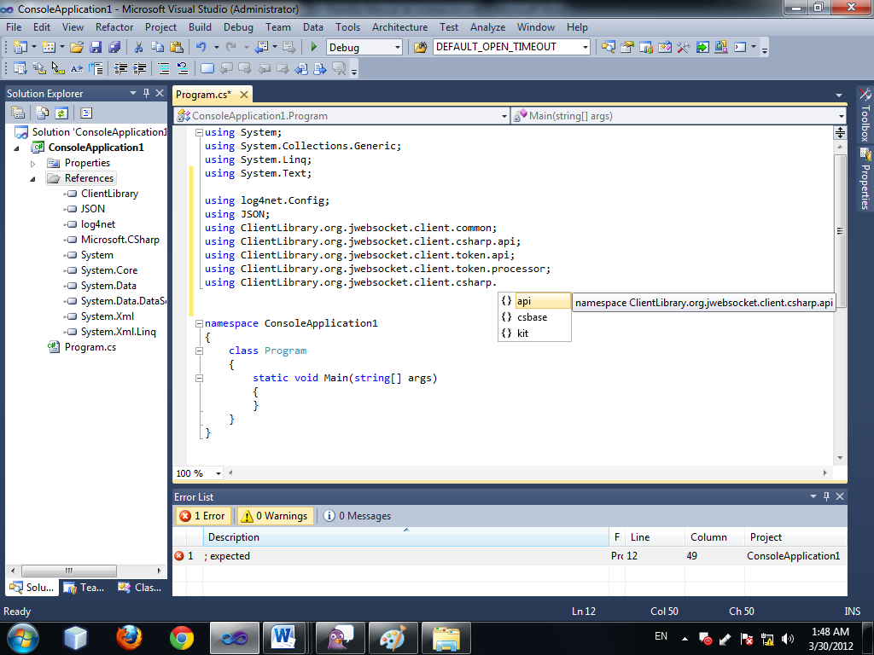
Picture 1: Add namespace

Hardware implementation (optional)
No need to specify hardware features.

Configuration Options
Using the Config.xml file you can change some parameters of the operation of the application. For example:
Max frame size <default_max_frame_sixe value= " value (ms) between 10240 and 1048840 " />
Time out to reconnect <default_open_timeout value=" value (ms) between 1 and 60000 " />
Time out to send ping <default_ping_timeout value=" value (ms) between 1 and 60000 " />
Delay to send ping <default_ping_delay value=" value (ms) between 1 and 60000 " />

Initial operation
You must specify the URL jWebSocket server. For example:
ws://localhost:8787//jWebSocket//jWebSocket

Application Management
“ws” protocol uses port 9797 for connect to the server.

“wss” protocol with SSL uses port 443 for connect to the server.

